Mr. Marcus Allen



Assistant Superintendent of Support Services

706-826-1302

Dear Parents,

As we look for ways to ensure our students are college ready, please be aware of a special program that will allow your child to take the ACT (American College Testing) and the SAT (Scholastic Aptitude Test) without cost to you. These tests are used by colleges and universities to determine college admissions and can cost up to $85.

The ACT (American College Testing) and The College Board (SAT, PSAT, AP) offer fee waivers to waive or reduce the cost of the ACT, SAT, AP, and PSAT exams for students from families who qualify under the criteria listed below. Qualifying students should speak with their counselors about fee waivers for these examinations.

To be eligible, students must meet ***at least one*** of the requirements below:

* Annual family income falls within the Income Eligibility Guidelines set by the USDA Food and Nutrition Service.

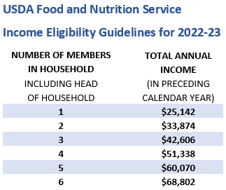

* Enrollment in a federal, state, or local program that aids students from low-income families (e.g.

Federal TRIO programs such as Upward Bound).

* Family receives public assistance.
* Lives in federally subsidized public housing, a foster home or is homeless.
* A ward of the state of Georgia or an orphan.
* My household receives TANF or SNAP or other public assistance.
* My family is homeless.
* My child is a foster child.
* My family has experienced a recent financial hardship.

By signing below, I am indicating that my family meets any one of the criteria outlined above.

Parent/Guardian Signature: __________________________________ Date: ______________

Student’s First and Last Name: ___________________________________________________ Learning Today... Leading Tomorrow

Office: (706) 826-1000 [www.rcboe.org](http://www.rcboe.org/)  864 Broad Street, Augusta, GA 30901